3rd April 2020

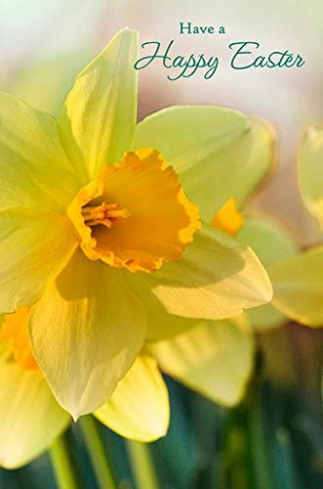

We would like to wish all our pupils, parents, staff and the whole school community a very Happy Easter. We hope you are keeping healthy and safe. We are thinking in a particular way of those of you working in the frontline services - especially in health and food related services – ‘Thank You’. We are thinking of the sacrifices you are making and it is particularly poignant given it is soon Holy Week.
We hope the sunshine will fill you all with Eastertime hope and renewed resilience against darkness.
Attached you will find some resources for Praying at Home during Holy Week. A Stations of the Cross for Children will be available on www.kandle.ie early next week. This will be a very different Holy Week but hopefully these resources will help families who wish to use them.
You have made it to the holidays - Enjoy a peaceful, quiet and restful break and eat loads of chocolate you all deserve it!! School is closed now for 2 weeks. We will all return to teaching and learning on Monday April 20th.
Stay safe and apart.
Sincerely
Ms McDonagh

